Practical No. 08

**Working with data controls**

**Aim:**

**a. Create a web application to demonstrate various uses and properties of SqlDataSource.**

**b. Create a web application to demonstrate data binding using DetailsView and FormView Control.**

**c. Create a web application to display Using Disconnected Data Access and Data Binding using GridView.**

**Name: Ankit Singh Chauhan**

**Roll No: 64**

**Class: T.Y.BSc.IT**

**Sub: Advanced Web Programming**

**Grade:**

**Sign:**

**Aim:**

**a.) Create a web application to demonstrate various uses and properties of SqlDataSource.**

**Code:**

using System;

using System.Collections.Generic; using System.Linq;

using System.Web; using System.Web.UI;

using System.Web.UI.WebControls; using System.Data.SqlClient; namespace prac8a

{

public partial class WebForm1 : System.Web.UI.Page

{

SqlCommand co = new SqlCommand(); SqlDataReader ds;

SqlDataSource s = new SqlDataSource();

protected void Page_Load(object sender, EventArgs e)

{

s.ConnectionString = "Data Source=LAPTOP-B1APOO4T\\SQLEXPRESS01;Initial Catalog=db1;Integrated Security=True" ;

}

protected void Button1_Click(object sender, EventArgs e)

{

s.SelectCommand = "select * from student;"; GridView1.DataBind();

}

protected void Button2_Click(object sender, EventArgs e)

{

SqlParameter p1 = new SqlParameter(), p2 = new SqlParameter(), p3= new SqlParameter(),p4 = new SqlParameter();

s.InsertParameters.Add("p1", System.Data.DbType.Int32, TextBox1.Text); s.InsertParameters.Add("p2", System.Data.DbType.String, TextBox2.Text); s.InsertParameters.Add("p3", System.Data.DbType.String, TextBox3.Text); s.InsertParameters.Add("p4", System.Data.DbType.String, TextBox4.Text); s.InsertCommand = "insert into student values(@p1,@p2,@p3,@p4);"; s.Insert();

}

protected void Button3_Click(object sender, EventArgs e)

{

SqlParameter p1 = new SqlParameter(), p2 = new SqlParameter(); s.UpdateParameters.Add("p2", System.Data.DbType.String, TextBox2.Text); s.UpdateParameters.Add("p1", System.Data.DbType.Int32, TextBox1.Text); s.UpdateCommand = "Update student SET name = @p2 where sno= @p1 ;"; s.Update();

}

protected void Button4_Click(object sender, EventArgs e)

{

SqlParameter p1 = new SqlParameter();

s.DeleteParameters.Add("p1", System.Data.DbType.Int32, TextBox1.Text); s.DeleteCommand = "DElete student where sno= @p1 ;";

s.Delete();

}

}

}

**Output:**

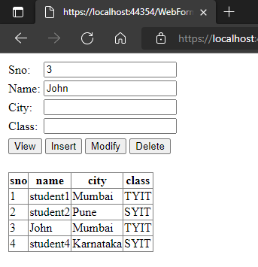

**Aim:**

**b. Create a web application to demonstrate data binding using DetailsView and FormView Control.**

**Code:**

**Output:**

**Aim:**

**c. Create a web application to display Using Disconnected Data Access and Data Binding using GridView.**

**Code:**

using System;

using System.Collections.Generic; using System.Linq;

using System.Web; using System.Web.UI;

using System.Web.UI.WebControls; using System.Data.SqlClient;

using System.Data; namespace prac8c

{

public partial class WebForm1 : System.Web.UI.Page

{

SqlConnection con = new SqlConnection(“ Data Source=LAPTOP-B1APOO4T\\SQLEXPRESS01;Initial Catalog=db1;Integrated Security=True");

protected void Page_Load(object sender, EventArgs e)

{

}

protected void Button1_Click(object sender, EventArgs e)

{

da = new SqlDataAdapter("select * from student",con); da.Fill(ds, "stud");

GridView1.DataSource = ds; GridView1.DataBind();

}

}

}

**Output:**

